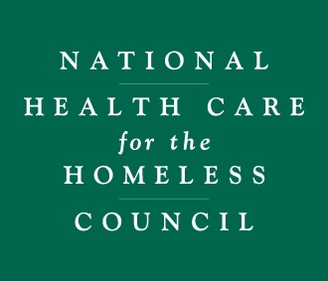

REIMBURSEMENT AGREEMENT
FY2019 JOHN N. LOZIER SCHOLARSHIP
As part of this Application for the John N. Lozier Scholarship for New Members for the 2019 National Health Care for the Homeless Conference and Symposium, I agree to the following:
Member Organization Representative:
- With the acceptance of this Scholarship, I understand that the Council is providing a Scholarship in the amount of $1,000.00 and this amount will first cover any registration fees to attend the FY2019 National Conference. Any remaining funds may be used to offset travel, hotel, or meal expenses as long as the reimbursement guidelines are followed.

- I understand that I or my organization will arrange travel and hotel reservations and will be responsible for any and all expenses that exceed the $1,000 Scholarship awarded.

- I (or the appropriate employee at my organization) will file a reimbursement request including original receipts no later than June 8, 2019. I understand that any submissions after this date will not be reimbursed by the Council.

- I have read and agree to the terms outlined in the Reimbursement Policy for Lozier Scholarship Expenses.

- If, for any reason, the Recipient is not able to attend, the registration and any other funds made available from this Scholarship Award is not transferable and the funds remain under the control and discretion of the Council.

Scholarship Recipient Signature: Click here to enter text.
Please Print Name: Click here to enter text.
Date: Click here to enter text.
Scholarship Recipient Supervisor’s Signature: Click here to enter text.
Please Print Name: Click here to enter text.
Date: Click here to enter text.

