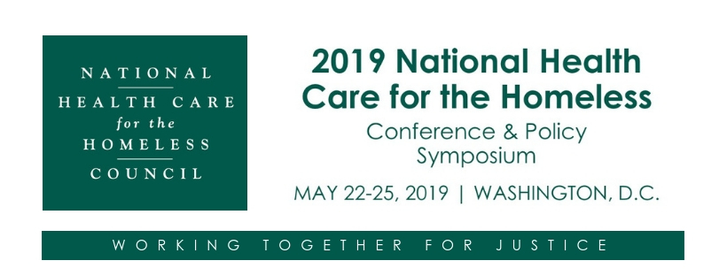

Track Information

Clinical & Hands-On Care Track

The goal for sessions in the Clinical & Hands-On Care track is to enhance the knowledge and skills of care providers in order improve the health and quality of life of people experiencing homelessness. Workshops may reflect an interdisciplinary approach to confront the multiple and complex problems associated with homelessness and a holistic manner of patient care.

We are particularly interested in proposals for sessions addressing:

- Behavioral health care
- Chronic disease management (e.g. diabetes)
- Children and families
- Aging
- Multiple comorbidities
- Substance abuse
- Population health
- Oral health
- Precision medicine
- Social determinants of health
- Involving patients in care planning

Policy & Advocacy Track

The Policy & Advocacy track is intended to highlight the efforts of the HCH community to create better public policy and achieve solutions to poverty and homelessness. This track is distinct from the Administration track in that it focuses on actions and partnerships external to the HCH project.

We are particularly interested in proposals for sessions that:
- Address systemic causes of poverty, inequity, and homelessness
- Address current events and/or policy issues that are widespread and significant within the HCH field
- Speak to experiences, outcomes, and constructive solutions (rather than simply advancing theory)
- Are applicable to other states and localities
- Promote a human rights approach to housing and health care
- Address disparities based on gender, income, race/ethnicity, housing status, or other social determinants of health
- Relate to the implementation of the Affordable Care Act, innovative uses of Medicaid, or advances in delivery system design
- Share experiences with unique or evolving partnerships (e.g., justice community, hospitals/insurers, public agencies, Continuum of Care, etc.)
- Pursue a single-payer approach to health care financing
- Promote social justice and/or social equity, and non-violence/prevention of violence as an approach to problem resolution

Administrative Track

The goal for workshops in the Administrative Track is to enhance the knowledge and skills of all levels of HCH leaders, including Executive, Medical, Finance, and HCH Project Directors. Workshops may address regulatory and policy issues affecting the operation of member agencies, including existing or proposed administrative program requirements issued by HRSA (PINS and PALS). Workshops will assist organizations that are interested in creating new health care for the homeless programs and services in their community as well as improve or expand existing programs.

We are particularly interested in proposals for sessions addressing:

- Effective care transitions
- Ways to promote culturally appropriate care, health literacy, and numeracy
- Balancing productivity and quality
- Financing and fundraising for quality care
- Staff development and retention
- Advanced technologies to improve care and quality of life
- Organizational models and characteristics related to favorable patient outcomes
- Quality assessment, Quality Improvement (QI) and Quality Assurance (QA) initiatives
- Health care delivery models that address the conditions of homelessness

Research Track

The purpose of the Research Track is to provide a venue for homeless health care researchers to: (1) share study findings that will inform practice and policy efforts to improve the quality of care for individuals who are homeless and (2) describe research processes and approaches that facilitate engagement of Health Care for the Homeless grantees in research. We are especially interested in research that is led by, or heavily informed by, patient and clinician stakeholders.

We are particularly interested in proposals for sessions that:

- Explore a new area of inquiry and ask an innovative research question
- Focus on marginalized homeless subpopulations, such as racial/ethnic minorities or gender minorities
- Focus on research areas of high interest the HCH field, such as chronic disease management, mental health issues, treating patients with multiple chronic conditions, substance abuse, and housing
- Describe the current health status of homeless populations (e.g., morbidity and mortality)
- Explore causes of homelessness and facilitators/barriers to exiting homelessness
- Describe interventions designed to improve disease self-management or health care delivery models and systems
- Address socio-behavioral aspects of homelessness and issues specific to the vulnerabilities related to homelessness
- Describe state and local efforts to address barriers to care
- Use a novel research design and methodology
- Utilize pragmatic research designs that are replicable in the health center setting
- Use client-centered research methods, like Community-Based Participatory Research (CBPR)
- Describe research collaborations between health centers, academic partners, and other research institutions
- Address challenges in conducting research with individuals who are homeless and in the homeless health care setting

TO SUBMIT A PROPOSAL ONLINE

https://www.cvent.com/c/abstracts/d01d524e-e96f-4226-b95d-645df61698f3

Submission Deadline: 10/29, 2018 at 11:59 PM, Pacific Time

