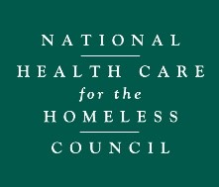
National Health Care for the Homeless Council Learning Collaborative on the Adoption and Implementation of Trauma-Informed Health Care for the Homeless Projects

Application Questions
*Limit of 200 words for each question

ORGANIZATION
- Describe your organization, services, and population served.
- What is the value for your organization participating NHCHC’s TIO LC? Include a description of long- and short-term goals.
- What has your organization achieved or worked toward regarding trauma-informed practices or frameworks on an organizational level?
- What have been successes or challenges you have experienced in implementing trauma-informed practices or frameworks on an organizational level?

INDIVIDUAL (for the primary liaison to complete)
- What is your personal experience engaging in trauma-informed practices or frameworks?
- What do you see as the personal value you will gain through participate in the NHCHC TIO LC?
- What potential barriers may you face engaging in the LC, and how would you address these barriers?
- After review of the background information for the learning collaborative structure and projects, what reactions or recommendations do you have? Response optional.

PARTICIPATION IN THE LEARNING COLLABORATIVE
- The TIO LC that will take place January 2018- June 2018 will require feedback on an organizational assessment tool and organizational implementation plan. What barriers do you envision in sharing this draft with all levels of your staff, receiving feedback, and sharing with the rest of the LC?

