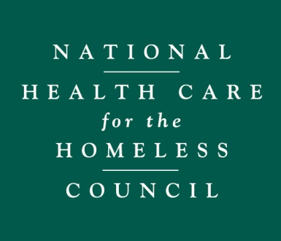
WORRIED ABOUT CHANGES
TO HEALTH CARE OR IMMIGRATION?

TWO IMPORTANT THINGS TO KNOW:
- Health Care for the Homeless will continue to provide health care services in this community, no matter what happens. We are not closing our doors.
- This is a safe space. We do not report anyone’s immigration status to law enforcement.
OTHER INFORMATION TO KNOW:
Congress and the Trump Administration want to make many changes to health care and it is easy to be confused and worried about what will happen to your benefits and your care. Here is some basic information:
- There have been no federal changes to your health insurance benefits—and there probably will not be changes in 2017.
- We don’t know what will happen with health reform. There are still many possibilities on what could happen—and it might mean that nothing will change here in our state.
- Any health reform changes being discussed will take effect in the future, and these changes can’t happen too quickly. It might be more than a year before we know what is finally decided, and then there needs to be time to make the changes.
- Ensuring you have a safe place to receive health care is our #1 priority. We do not provide patient information to federal immigration agencies.
- We are talking with elected officials and letting them know that Medicaid coverage is important for our clients.
- Want to express their views to elected officials also? Please do! On the back of this page are some tips on how to call and what you might want to say.

ACTIONS YOU CAN TAKE:
Call your Senator and tell them your concerns!
What you need to know: Right now Congress is talking about changing the Affordable Care Act (also known as Obamacare). Obamacare gave states the option to expand their Medicaid programs. Patients at Health Care for the Homeless clinics are five times as likely to have gained insurance if they live in a state that expanded Medicaid. Some members of Congress are suggesting changing Medicaid to be a set amount of money for the state (“block grants”) or a set amount of money per person (“Per Capita Caps”). Both these changes would reduce Medicaid funding and the services available to people in need.
Who to call: The Capitol Switchboard line will connect you with any Senate office 202-224-3121
OR--
Write in your Senator’s name and number here:____________________________________
Write in your Senator’s name and number here:____________________________________
What to say: You don’t need to be an expert on Obamacare to call. A staff member or answering machine will pick up the call—make sure you leave a message. Keep your message short and polite. They keep track of how many calls they get on each topic so they know what’s important. Your call needs to be counted!
“Hello my name is ____ and I live in ____________ and Medicaid is important to me because _____________________. I would like to leave a message for Senator _____. Medicaid Expansion is a vital program for people who are homelessness. Changing Medicaid to Per Capita Caps or Block Grants would only cut services & not give us the care we need. Please let the Senator know I am worried about these changes and ask him/her to support the Medicaid program. Thank you for your time.”
- If your state DID NOT expand Medicaid you can add : “Please tell the Senator we need Medicaid expansion in our state and do not limit the funding through these harmful proposals.”
- If your state DID expand Medicaid you can add: “Medicaid expansion has helped so many people in our state and please tell the Senator I hope she/he will fight to keep it.”
If you want to say more, block grants and per capita caps…
- …are only federal funding cuts and just shift the cost to the state without making people healthier.
- … will force states to make tough decisions to cut benefits, cut provider rates, or cut eligibility. This will make it much more difficult to provide care to those experiencing homelessness.
- … make it difficult to deal with things like public health emergencies, economic downturns or natural disasters.
- … make it more difficult for the state to invest in strategies like addiction treatment, case management and housing support services, which are working to prevent and end homelessness.
For more information contact Regina Reed, National Health Policy Organizer, rreed@nhchc.org

